Bhye Muzaffar Alii Rohomuthally

Final Report

List of problems detected:

1. There is no success/failure message after editing account details.
Category: No “Provide feedback”
Severity: High

2. When user enter new password, does not check if new password is blank
Category:No ”Good error message”
Severity: Medium

3. There is no success/failure message after confirming identity
Category:No “Provide feedback”
Severity: High

4. There is no check for username on confirm identity page
Category:No “Good error message”
Severity: Medium

5. There is no check for security question on confirm identity page
Category:No “Prevent error”
Severity: Medium

6. The link “Click here to recover password” is too close to the password textbox.
Category:No “Provide Shortcuts”
Severity: High

7. Homepage text should be made bigger.
Category:No “Simple and Natural Dialogue”
Severity: High

8. Can register multiple course with same name
Category: No “Error prevention”
Severity: Medium

9. Can drop 1 course more than once but there should be have been an error message
Category:No “Error prevention”
Severity: Medium

There are many things that need to be addressed. Places where there should be a feedback message, there is none. Some texts could have been made simpler. All the evaluators (3 in total) said the interface was simple, which I think is good. It does not have too much color, good for color blind people. I suppose all the buttons had informative text as there was no problem regarding the button from the evaluator. The home and the sign out worked well and there were no issues mentioned regarding those buttons from the evaluators. There are some places where checks are not made. I forgot to implement those checks but they do not produce errors and the interface continues to work.

Besides the problem mentioned above, all of the places provide good feedback when the user is clicking or something. The account details work well but after changing the information, the values are not made permanently as they are hard coded data.

The course details gives a list of courses that are available and shows details for each course. That part works well for a high fidelity prototype. The register course works too, if the user wants to see what happens when they try to register a course, they will see the changes. I think this feature was well implemented.

It is the same for the drop courses, it starts with a list of already registered courses every time, as hard coded data. When the user wants to drop a course, they will see the changes happening in this prototype.

Register and drop course page provides a link to course details which is a feature to make it easy for users to navigate the system. When a user wants to register/drop a course and they want more details on whether it is the right course they are choosing , they can use the link to go directly to course details.

Error messages:

1. Login Page:

As the user begins to fill out the form on the login page, they enter their username and password into the designated fields and if those credentials are not valid or not found. However, as they move on to click on the login button, an error message pops up on the top of the screen. The message reads, “Username or Password not found. Please enter a valid username or password”

The user will realize that they made a mistake and they can correct their credentials, double checking to make sure it is correct before moving on. They will be able to see a clear and concise error message, which clearly indicates what the issue is and how to fix it.
Overall, the webpage’s error message is effective at communicating to the user when they have made a mistake and how to fix it, making the process of filing out the form smooth and hassle-free which also conforms to one of Schneiderman’s golden rules “Offer informative feedback”. Here is a sample image (zoom to see image clearly)

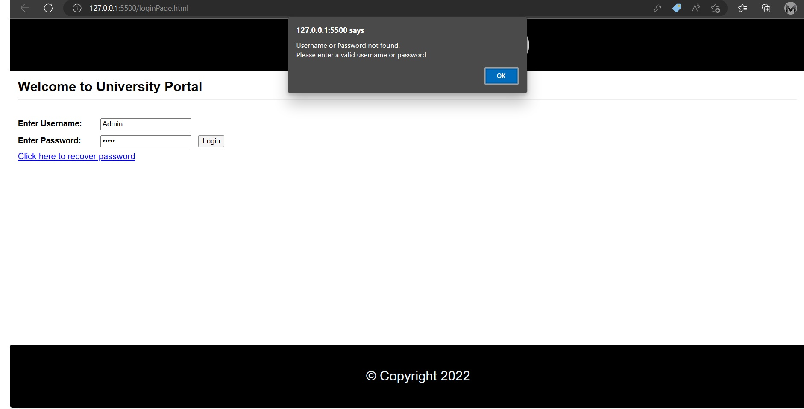

2. Register course:

As the user begins to search for a course on the webpage, they type in the name of the course they are interested in. However, when they hit the “click to register” button, a message appears indicating that the course they are looking for could not be found. The error message reads, “Sorry, the course you are looking for could not be found.\nPlease check the spelling and try again or contact the administration office.”.
The user will find that the course they were looking for is not available, but they will understand the clear and helpful error message. The message clearly explains the issue and provides suggestions for how to resolve it, such as the spelling or contacting the administration office.
After seeing that error message, the user can double check the spelling of the course name and try the search again. The effective error message helped the user quickly identify and fix the issue, allowing them to smoothly complete their task on the register course webpage. Here is a sample image: (zoom for more clear view of the image) 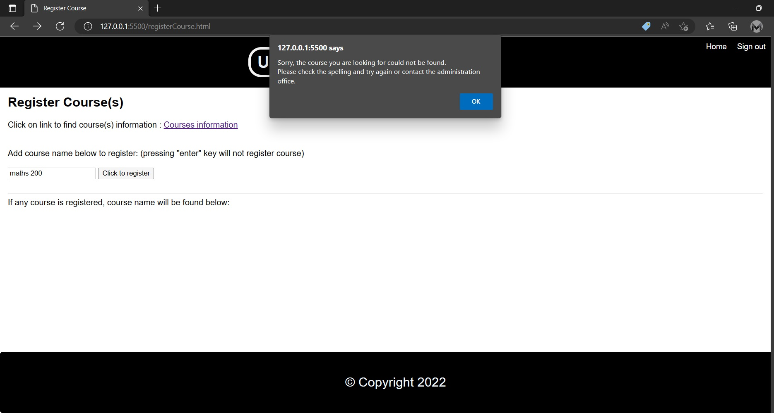

3. Drop Course:

As the user navigates to the webpage to drop a course, they begin to enter the name of the course they want to remove. When they try to click on the “Click to drop course”, an error message appears indicating that the course they entered is not valid. The message reads, “Sorry, the course you entered is not valid. Please check the spelling and try again or contact the administration office for more support.”.
The user will be grateful for the clear and helpful error message, which promptly alerts them to the issue and provides suggestions for how to resolve it. They can then double check the spelling and try again, successfully dropping the course they no longer wish to take.
The effective error message provided by the webpage will make it easy for the user to identify and fix the issue, allowing them to smoothly complete their task of dropping the course.
Below is a sample image (zoom page to see clearly):
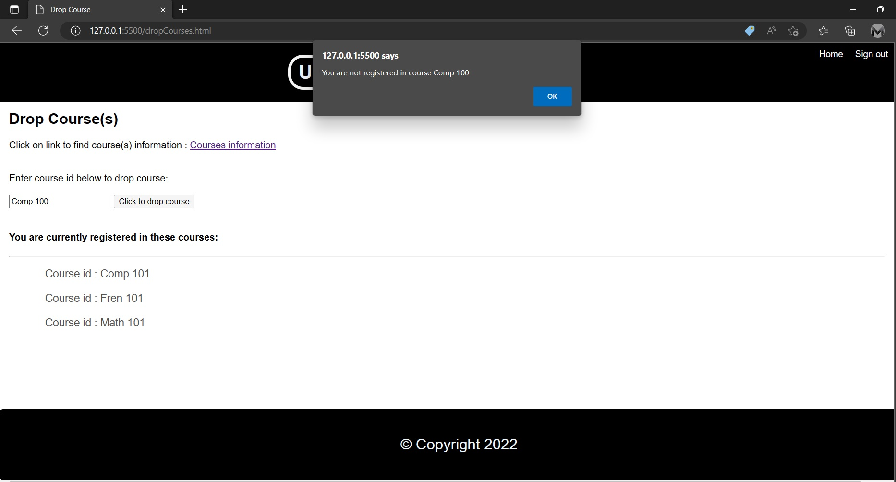

Shortcuts:

I have designed the web pages with the user’s convenience in mind. On every page of the website, there is a button labeled “Home” located on the top right corner. This button serves as a shortcut, allowing the user to quickly navigate back to the homepage at any point.
The presence of this shortcut makes it easy for the user to navigate the website and find what they are looking for. They can easily return to the home page to browse for other content. The shortcut also saves the user time, as they do not have to manually navigate back through the website or use the back button in their web browser.
Overall, the website’s use of the home button improves the user’s experience by making it easier and more efficient for them to navigate the site.

Reducing short term memory load:

To conform to HCI guidelines, it is important for the university portal to be designed in a way that reduces the short-term memory load on users.
To reduce short term memory load on the website, I implemented a number of design principles. First, I used clear and concise language to convey information. This helped to eliminate any confusion or misunderstandings that users may have.
Next, I used visual hierarchy to break up the text and make it easier for users to scan and understand the content of the web pages. This included using heading and subheadings to organize the information. In addition, I used whitespace effectively to separate different elements on the page and make the layout more visually straightforward.
Finally, I used a simple and consistent design throughout the website to help users understand the structure and organization of the contents. This included a consistent color scheme and layout. By following these design principles, I was able to create a website that was easy to navigate and understand. Users will be able to process and retain information more effectively, which helps to reduce the short term memory load on them.

In conclusion, keeping the design of a website simple is an effective way to reduce short term memory load on visitors. By using clear and concise language, implementing a visual hierarchy, using whitespace effectively, and using a simple and consistent design, I was able to create a user-friendly website that meets the needs of the users.

Design dialogs to yield closure:

Register course:

Designing dialogs to yield closure is an important aspect of user experience and HCI guidelines, particularly after a user has completed a task such as registering for a course. Closure refers to the sense of completion or resolution that users feel after completing a task, and it can have a significant impact on their overall satisfaction with the task.
It is important to clearly communicate to the user that the task has been completed. This can be done through the use of clear and concise language. Here is a sample image on giving a message after doing a successful task:
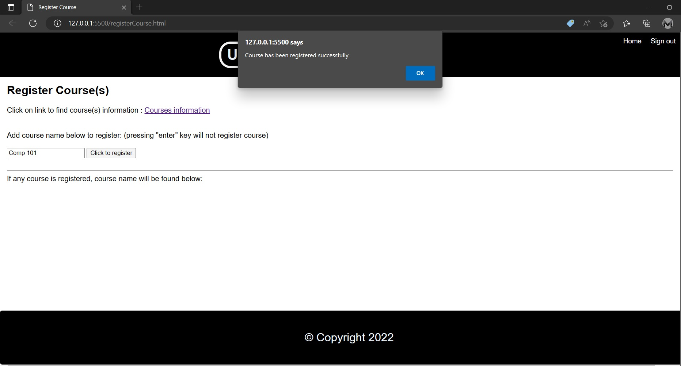
In addition, it is important to allow users to review and confirm the actions. This can be done through the use of summary screen or a confirmation text box that allow the user to review their information and ensure that everything is correct before moving on.

By designing dialogs that yield closure, we can create a positive and satisfying user experience for users who have completed the task for registering for a course. This can help to improve user satisfaction.

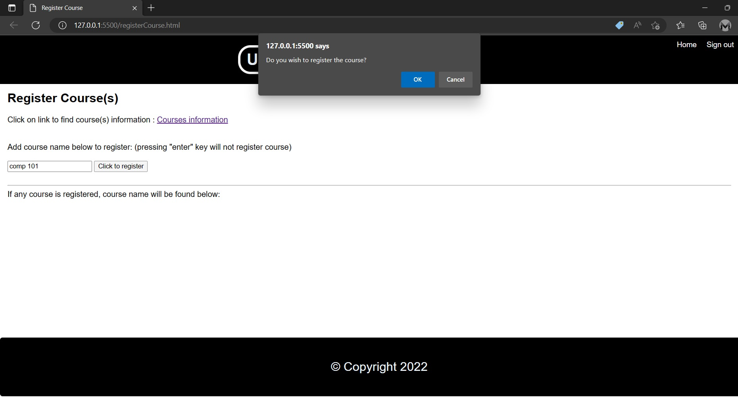

Drop course:
One important aspect of the university portal is the ability for students to drop courses that they are enrolled in. However, it is important to ensure that the process of dropping a course is clear and straightforward for the user. In addition, it is important to provide the user with a confirmation message after they have successfully dropped a course, to ensure that they are aware that the action has been completed.
To design a website that provides a good display message after a user drops a course, several factors need to be considered. First, the drop page should have a clear and intuitive layout, with clear instructions on how to drop a course. This also includes a dedicated section on the home page, with a link that allows the user to access the course drop function.
Once the user has accessed the course drop function, they are presented with an interface that allows them to type the course id that they wish to drop. The interface is easy to use, with clear labels and instructions. It also includes a confirmation step, where the user is asked to confirm their intention to drop the course before the action is completed. Here is a sample image of the step below:
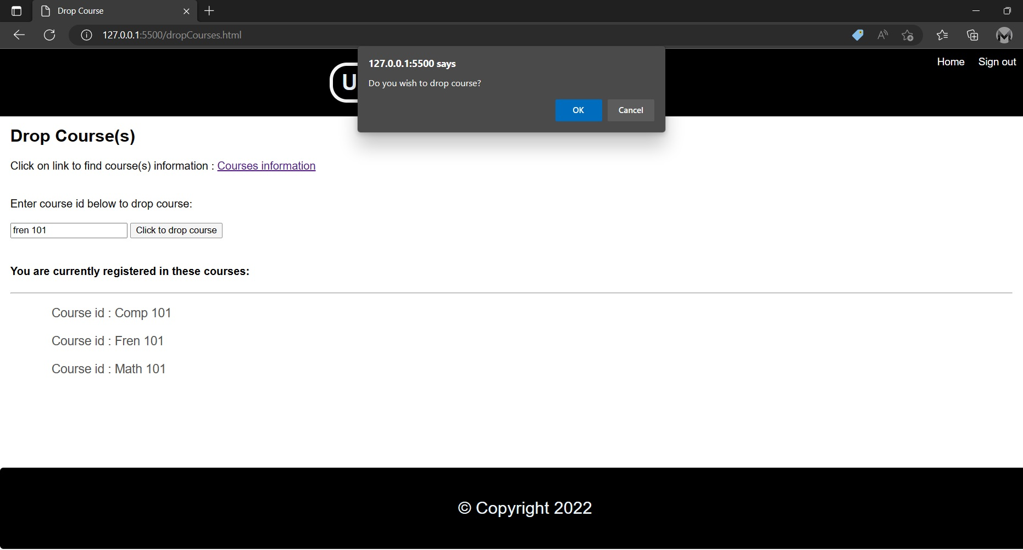

Once the user has successfully dropped, they are presented with a confirmation message tat clearly states that the action has been completed. This message is prominently displayed on the screen.
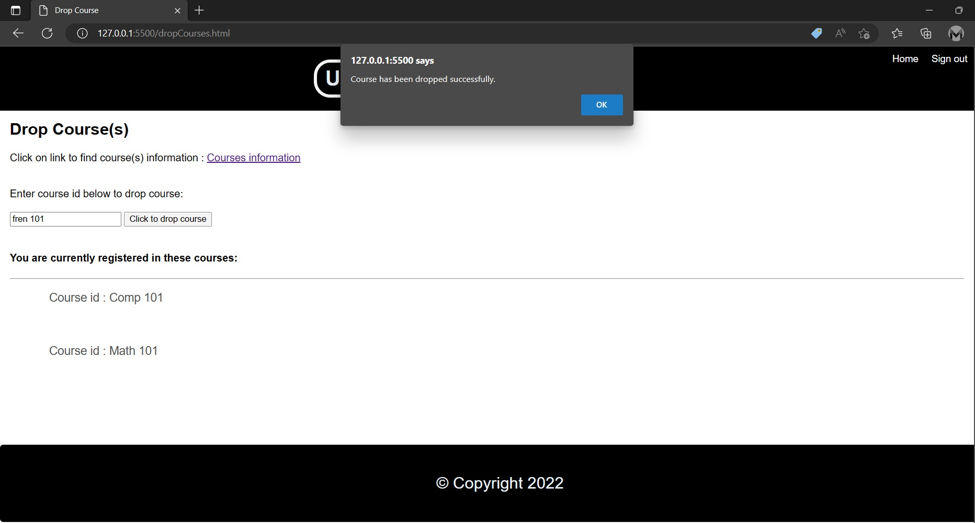

By designing a website with a clear and intuitive layout, and by providing the user with a confirmation message after they drop a course, the university portal can ensure that the process of dropping a course is smooth and straightforward for the user. This can help to improve the overall user experience of the website, and can help to ensure that students are able to effectively manage their course enrollment.

How it conforms to HCI principles

To make the university portal interface conform to HCI principles, I have followed the widely accepted set of principles for designing user-friendly interfaces known as Schneiderman’s Eight Golden Rules of interface design. I have included all possible rules that I could manage to integrate into the system. I will outline all the rules that I have used to design the website.

The first is “Strive for consistency”, which means that the website should use consistent language, layout and navigation elements throughout. To achieve this, we have used a consistent color scheme and font style, and have placed all navigational elements in a standard location on each page.

“Enable frequent users to use shortcuts”. This has been already discussed above in the shortcut section.

“Offer informative feedback,” which means that the website should provide users with clear feedback on their actions. To meet this criterion, we have included visual feedback whenever a user completes or fails a task.

“Support internal locus of control” which means that the website should allow users to feel in control of their actions and should provide them with clear and concise instructions on how to complete tasks. To meet this criterion, we have provided detailed instructions on each page, that walk users through key tasks.

“Design dialogs to yield closure”, and “reduce short-term memory load” has already been discussed above.

By designing a website that conforms to most of the applicable Scheiderman’s Eight Golden Rules of Interface Design, we have created an interface that is easy and enjoyable to use, and that helps to ensure that users are able to complete tasks efficiently and effectively. By following these principles, we have created a user-friendly university portal that meets the needs of both experienced and novice users.

Final opinion:
In my opinion, the password recovery process could be improved by more effectively verifying user identity. If I had more time, I could have also made changes to the account details page. However, the interface is simple and easy to use, with only black and white colors. While it was originally intended for use by administration staff, lecturers and students, due to time constraints it is only available to students. Despite this, students should still be able to perform the primary tasks of registering and dropping courses. Overall, while there are some areas for improvement, I am generally satisfied with the system.

Flowchart of the system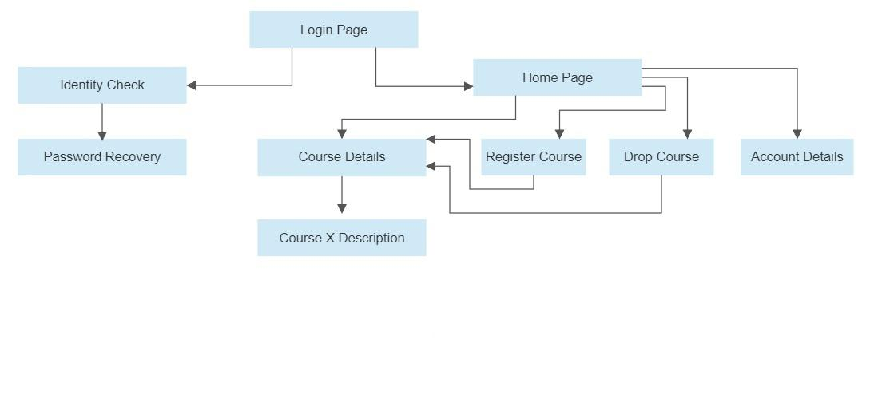

Some sample screenshots:

Identity Check Page:
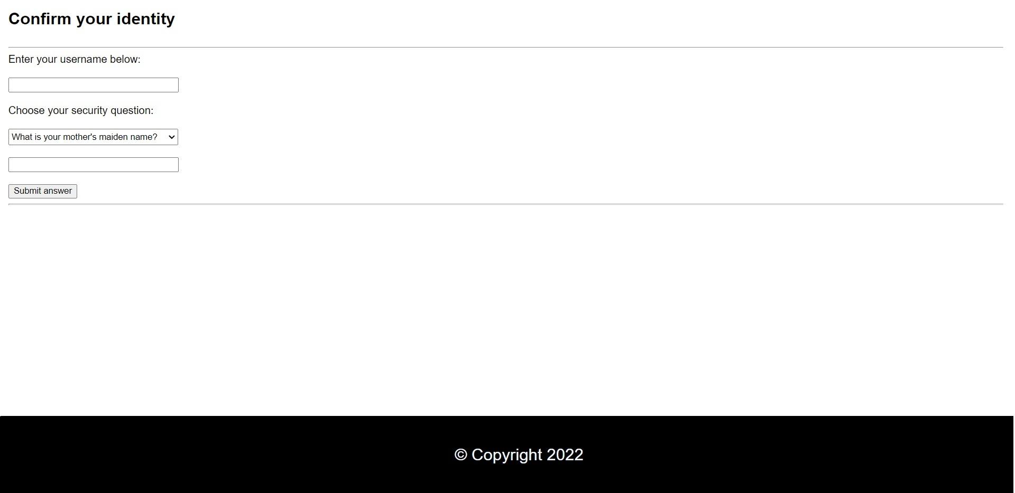

Password Recovery:

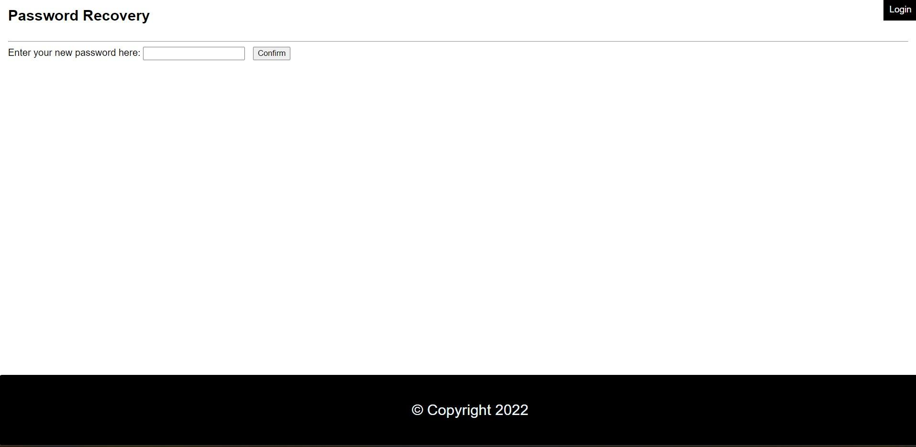

Home Page:
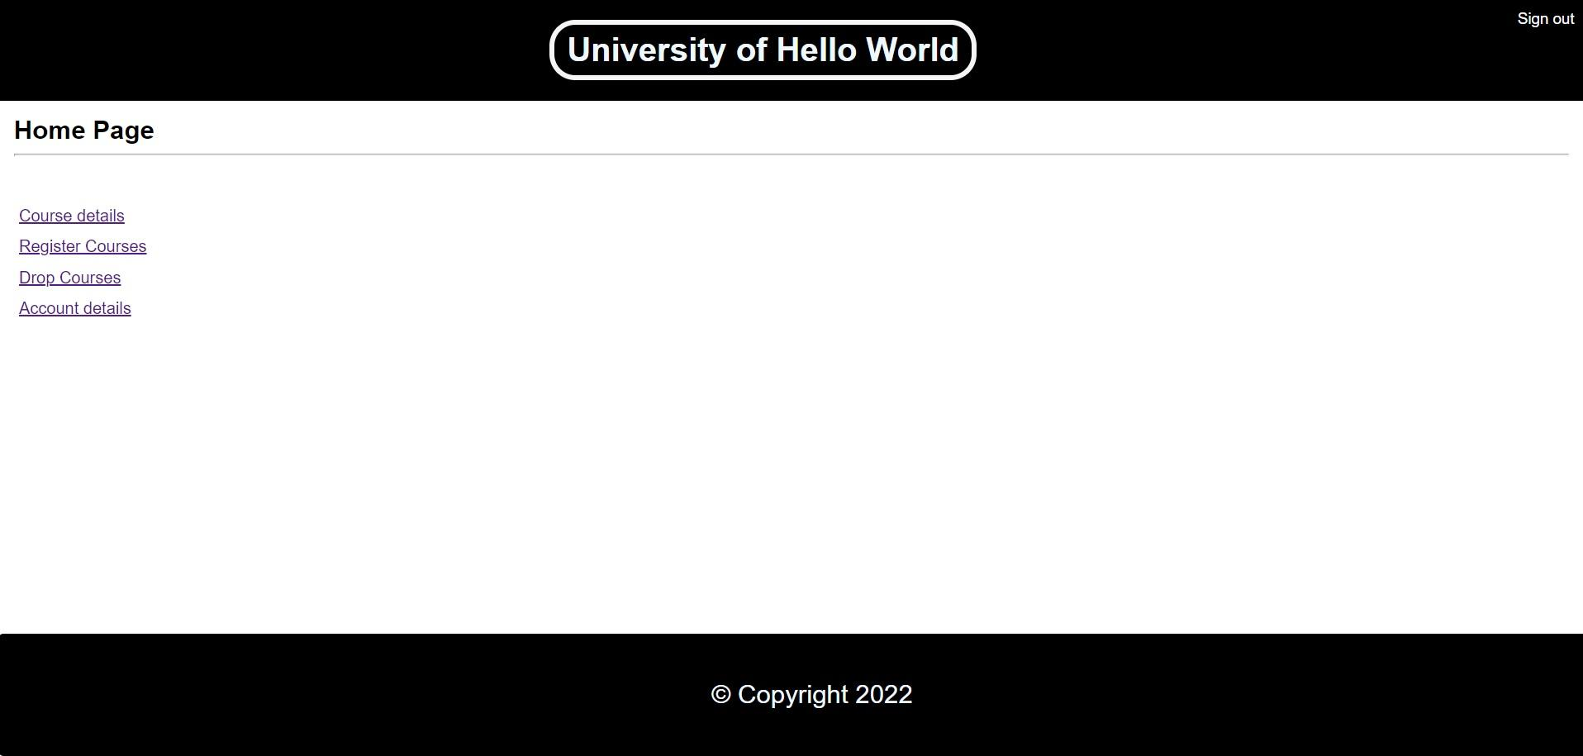
Course details:
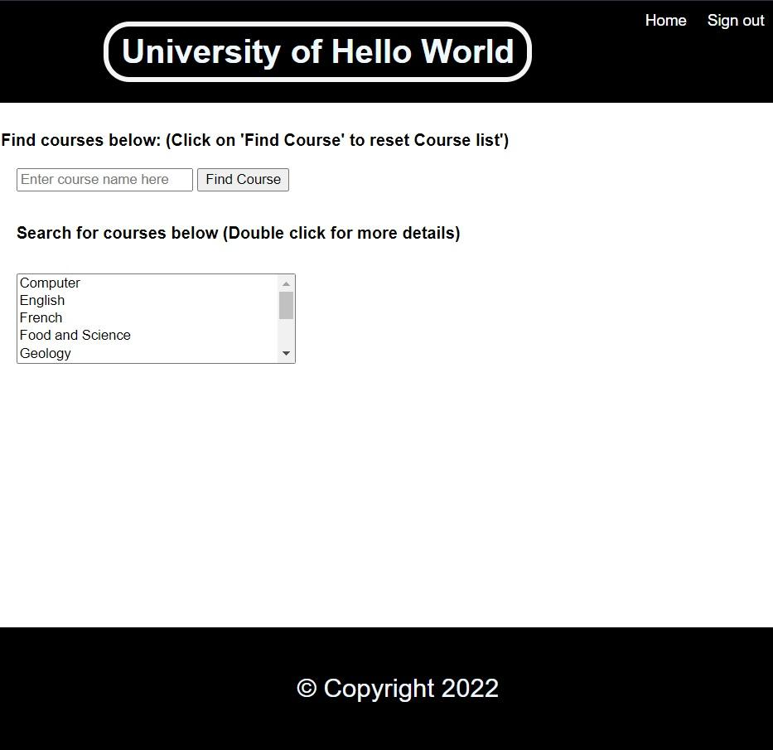
Course X description:
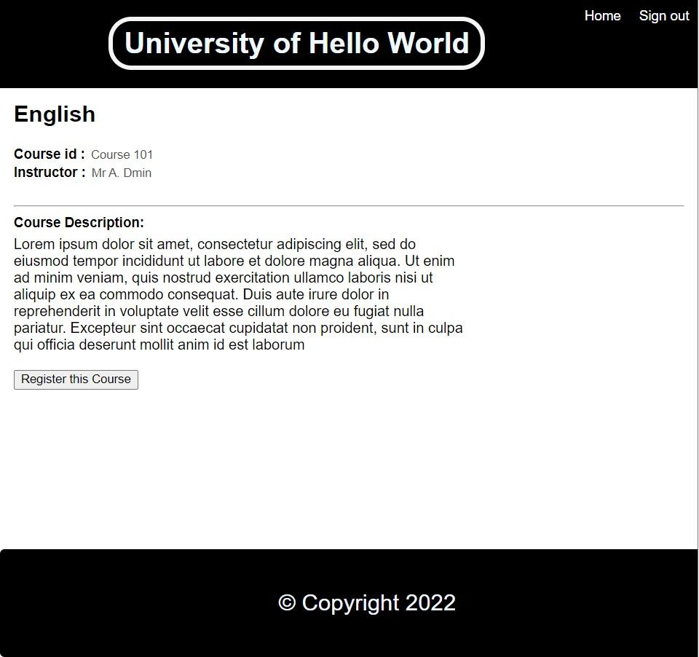
Drop Course: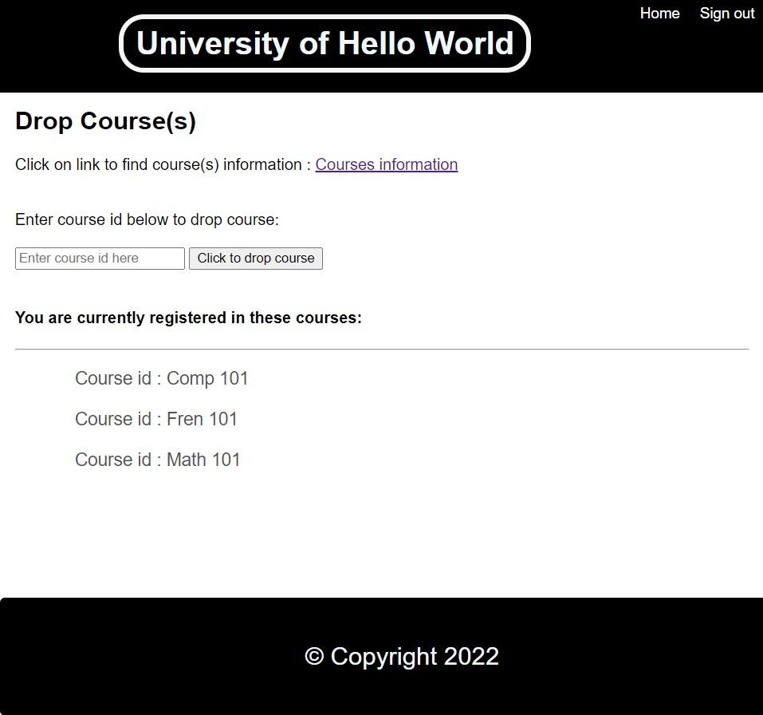

Account Details:
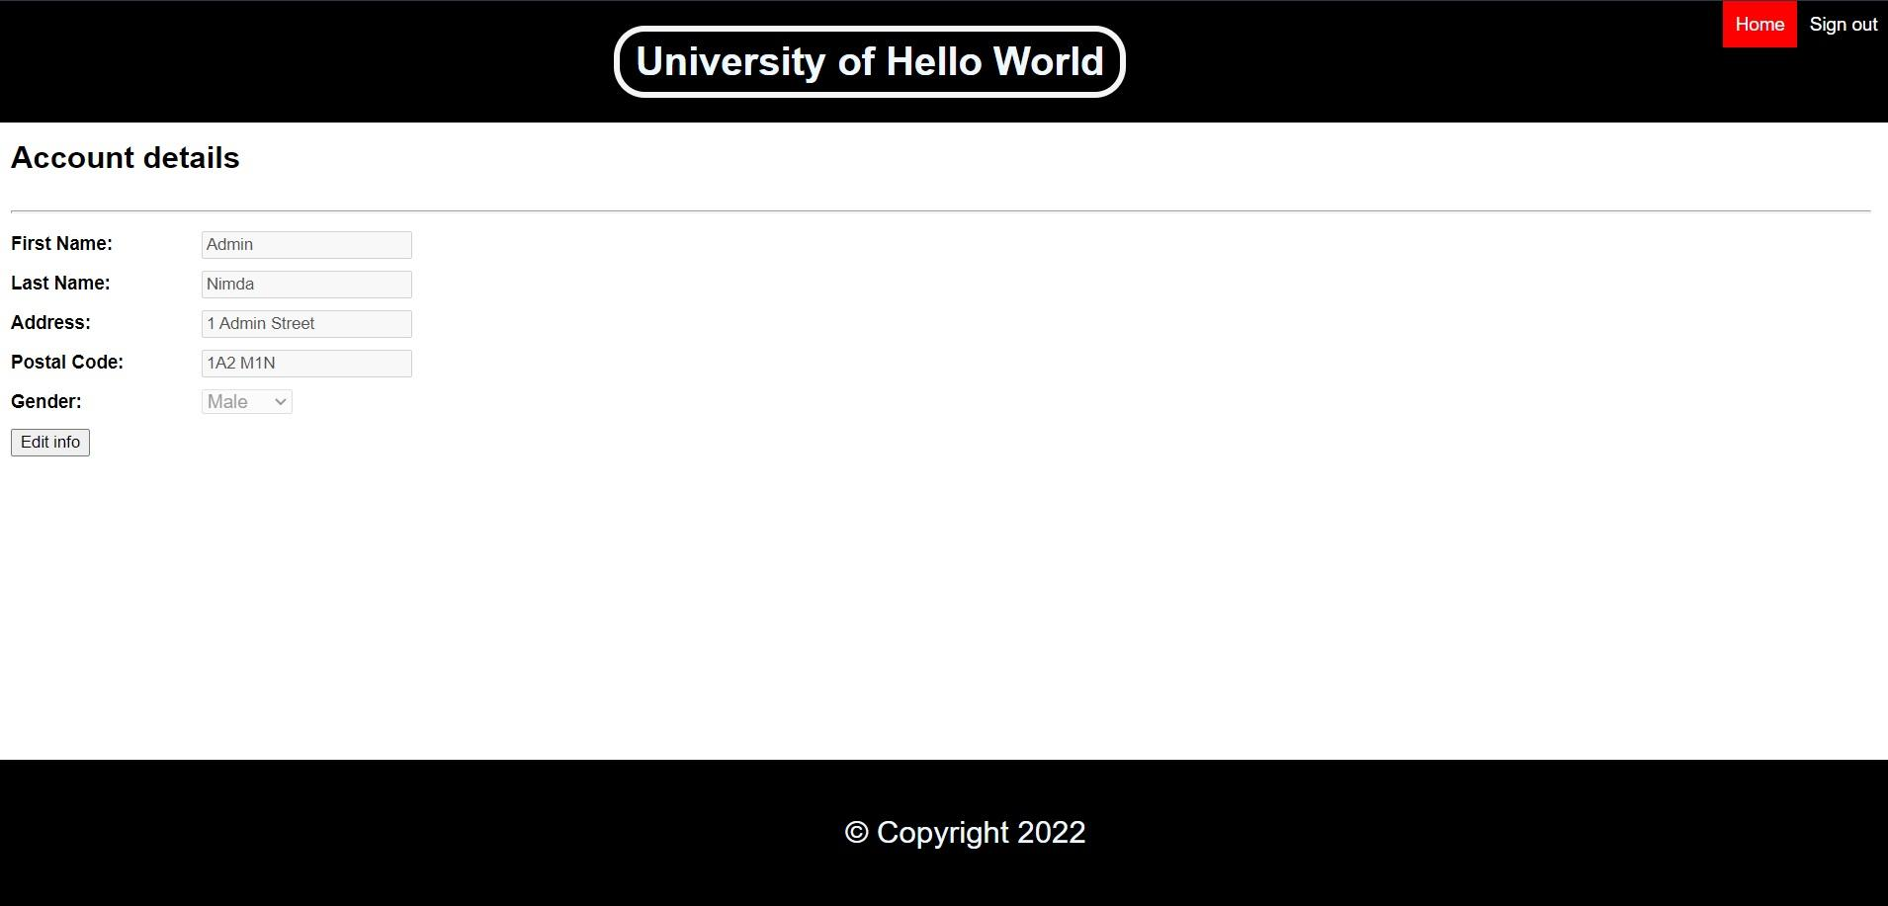

Link for the presentation : High Fidelity System

